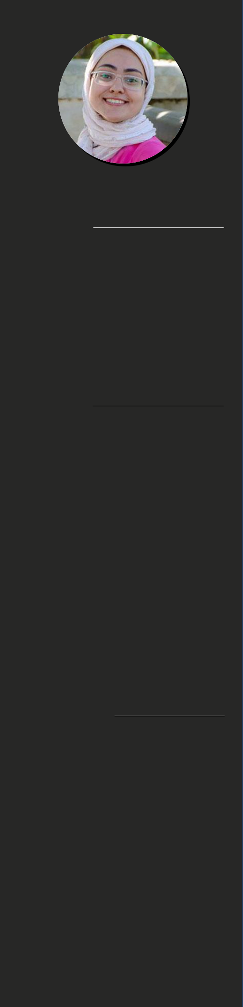

PROFILE

Dedicated Web Developer with experience creating portfolios and several other websites.

Strong collaboration skills

CONTACT

PHONE

01017286932
Marwa Sayed Mostafa

Full stack Web Development

WORK EXPERIENCE

Mar. 2020 - May. 2020 Creator (Part Time)

Dec. 2019 - Feb. 2020 Training in Ibda3 center

CERTIFICATIONS

Jul 2018  Full Stack Web Development Diploma

Mar 2017  CCNA at Al-Azhar (Asence)

Mar 2016 Arduino Projectat Al-Azhar (AZ-SENCE)

COURSES & ACTIVITES
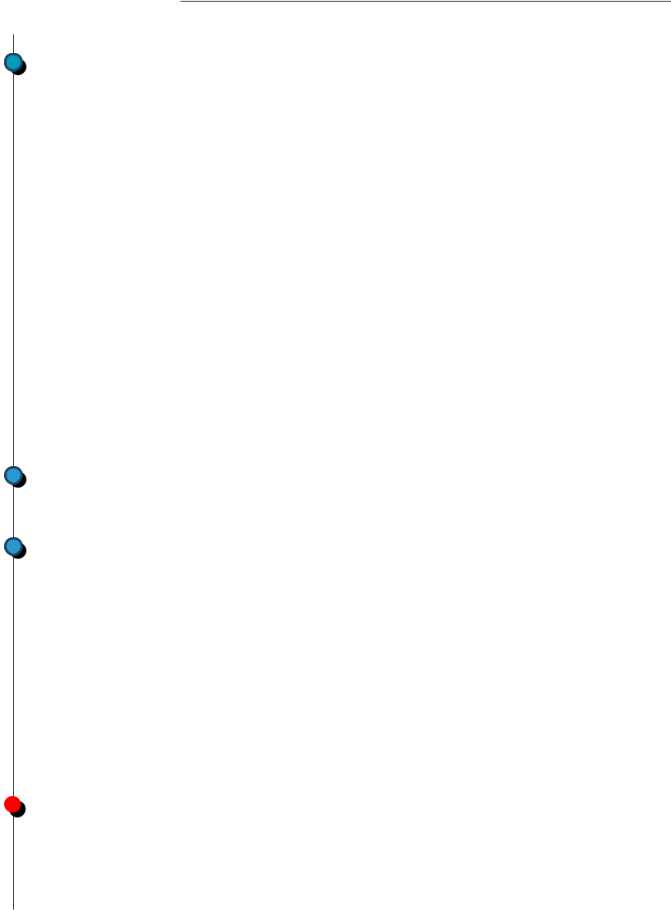

2018
Full Stack Web Development

Mail

marwa120640@gmail.com

Address

7_Hassan El-Debiki, Nozha El-Gedida

Social Media

GitHub

July - November

2017

January - April

I have got an Experience in:

- Html 5.

- CSS3.

- BootStrap4, Materialize.

- Regular Expression.

- Aware of new tools & Software Programs.

- Good at searching.

- C++ Programing.

- Fabric.js.

For UI Design :AdobeXD CCNA at Al-Azhar (Asence)

- JavaScript.

- JQUERY.

- SQL.

- PHP.

- Laravel.

- Vue.js.

- Ajax.

- Restful API.

- Git Commands.

Username: Marwa124

Stack Overflow

YouTube

LinkedIn

marwa120640@gmail.com

2016

January - April
Arduino Programming

Joined at Al-Azhar Exhibition for engineering applications,

Making a project using the Arduino and LCD to display Time, Date, Temperature, Stopwatch, also using infrared and ultrasonic sensors and designed a Game which displayed at LCD.

Skills I am working on develop it:

- Node.js

- Linux.

EDUCATION

Bachelor's Degree in computer and control

Al-Obour High Institute for Engineering and Technology Graduated in 2019 with Very Good Degree

Got Excellent Degree in GP (Microcontroller and Mobile Based control for Home Automation)

LANGUAGE SKILLS

English: Reading | Writing | Listening | Speaking
Advanced | Intermediate | Advanced | Advanced

